Name
Light Notes

A prism can _______________________ ___________________

The colors that we can see are:

______________________________________________________

We use the name ____________________________ to help remember.

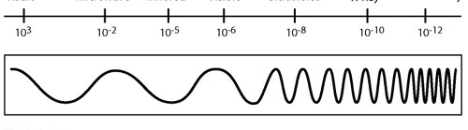
How much of the scale is visible light?:

Longer waves have ____________ energy

Smaller waves have ___________ energy

________________________________ can be harmful to your body!
Diagram how we see color:

(Circle the correct choice)
If we look at a plant and see GREEN, it is because it
Absorbs / Reflects : Red, Orange, Yellow, Blue, and Violet
Absorbs / Reflects : Green

All objects give off _______________________ ______________________ because of the thermal energy they release.

How can Infrared Cameras help Astronomers (People studying Astronomy: Space, stars, planets…) ?

SUMMARY:

